AMRUTA INSTITUTE OF ENGINEERING AND MANAGEMENT SCIENCES – POLYTECHNIC
Course: Database System Concepts and PL/SQL
Course Code: 20CS34P
Week 2
1. Identify and ER model elements and draw ER diagram for the given specifications using tools.
ER Model Elements
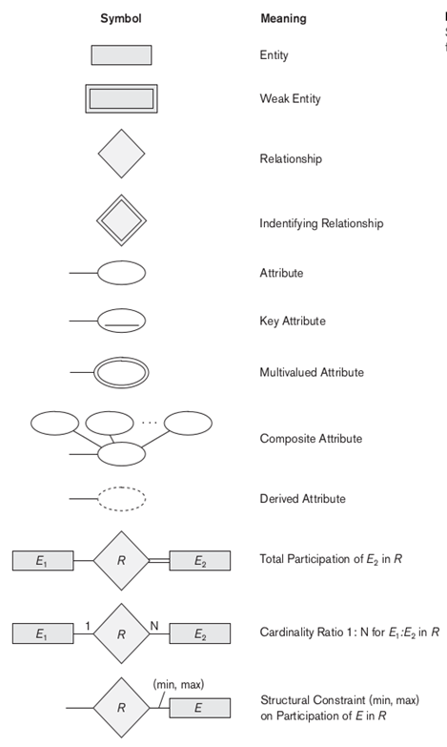

ER Diagram For Company Database
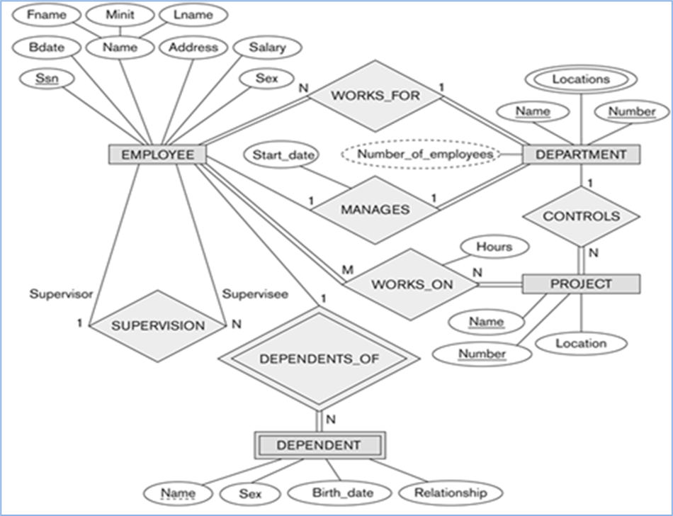

ER Diagram for Library Database
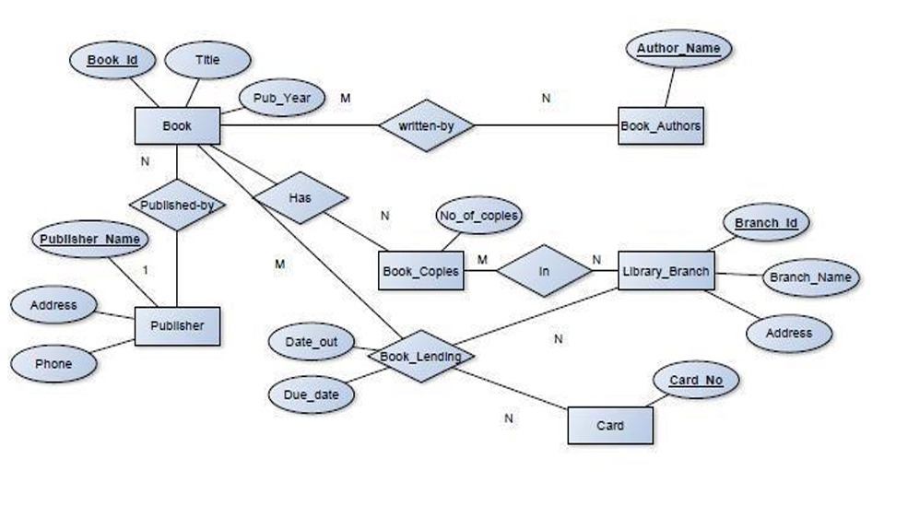

ER Diagram for IA Marks Database
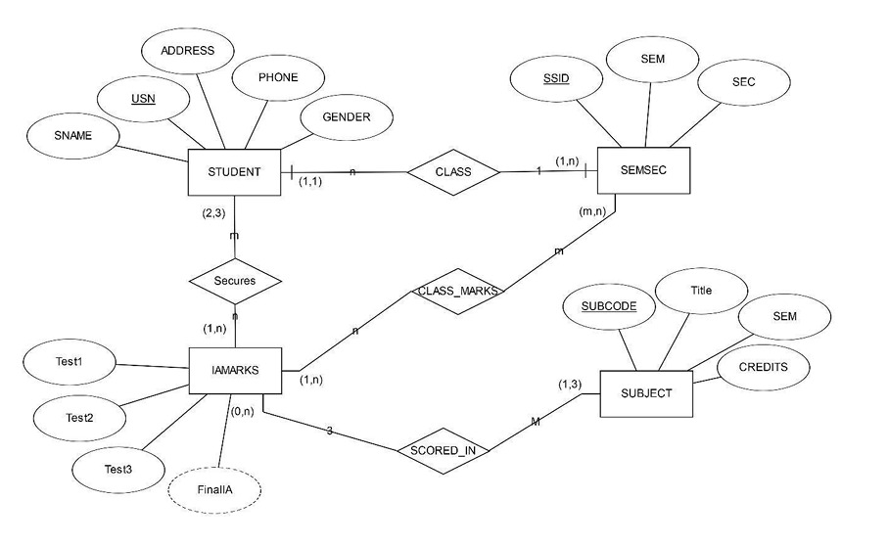
Week 3
- Map ER Model to relational model
- Identify various constraints

- Schema diagram for the COMPANY relational database schema.
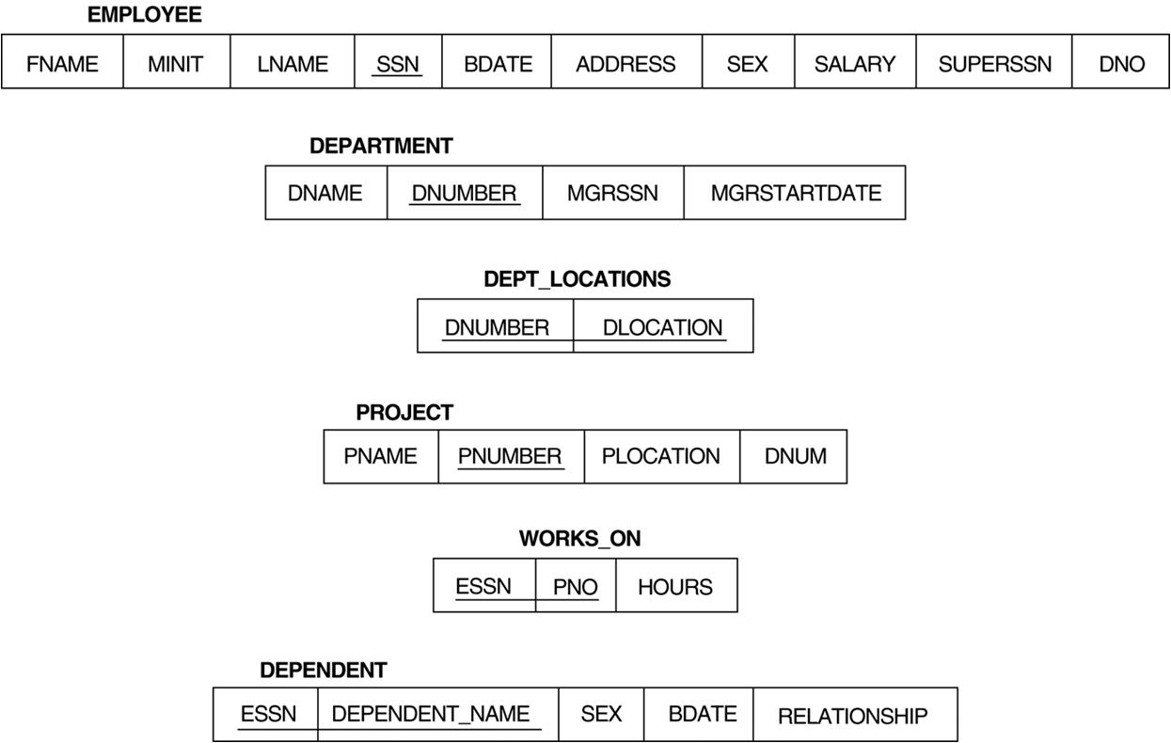

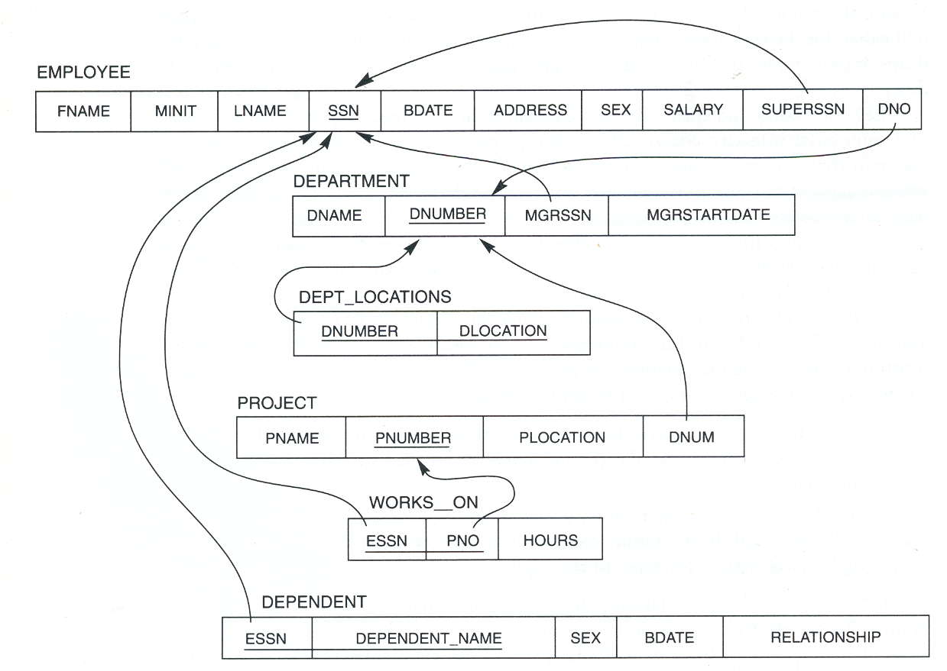
- Identify various Constraints
Referential integrity constraints displayed on the COMPANY relational database schema.
The schema-based constraints include
- Domain constraints,
- Key constraints and constraints on NULLs,
- Entity integrity constraints, and
- Referential integrity constraints.
- Domain Constraints
Domain constraints specify that within each tuple, the value of each attribute A must be an atomic value from the domain dom(A).
- Key Constraints and Constraints on NULL Values.
- A relation is defined as a set of tuples and all elements of a set are distinct; hence, all tuples in a relation must also be distinct.
- This means that no two tuples can have the same combination of values for all their attributes.
- Entity integrity constraint
- The entity integrity constraint states that no primary key value can be NULL.
- This is because the primary key value is used to identify individual tuples in a relation.
- Having NULL values for the primary key implies that we cannot identify some tuples.
- For example, if two or more tuples had NULL for their primary keys, we may not be able to distinguish them.
- Referential Integrity Constraints, and Foreign Keys
- Key constraints and entity integrity constraints are specified on individual relations.
- The referential integrity constraint is specified between two relations and is used to maintain the consistency among tuples in the two relations.
- Informally, the referential integrity constraint states that a tuple in one relation that refers to another relation must refer to an existing tuple in that relation.

For Example: The attribute Dno of EMPLOYEE gives the department number for which each employee works; hence, its value in every EMPLOYEE tuple must match the Dnumber value of some tuple in the DEPARTMENT relation.

Week 4
Normalize the above design
First Normal Form (1 NF)
- 1NF disallows multi valued attributes, composite attributes, and their combination.
- The only attribute values permitted by lNF are single atomic values.
- 1NF disallow “relations within relations" or "relations as attribute values within tuples."
Ex:-consider the DEPARTMENT relation schema , whose primary key is DNUMBER

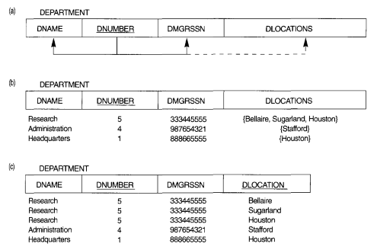

Normalization into 1NF. (a)A relation schema that is not in 1NF.
(b) Example state of relation DEPARTMENT.
(c) 1NF version of same relation with redundancy

Second Normal Form (2 NF)
Second normal form (2NF) is based on the concept of full functional dependency.
Definition: A relation schema R is said to be in 2NF if:
a) It satisfies 1 NF and
b) Every nonprime attribute A in R is fully functionally dependent on the primary key of R.
Ex In Figure (Employee and Project table)
{SSN, PNUMBER} → HOURS is a full dependency because HOURS is dependent on primary key {SSN, PNUMBER}.
But, SSN → ENAME and PNUMBER→PNAME dependency is partial because ENAME and PNAME are dependent on part of the primary key i.e SSN and PNUMBER.
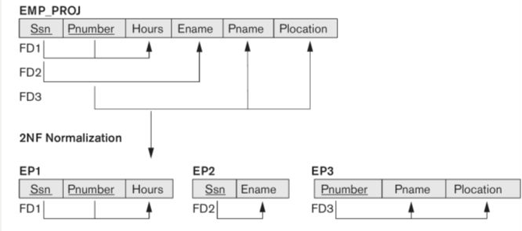
Normalizing EMP_PROJ into 2NF relations

The EMP_PROJ relation in Figure is in INF but is not in 2NF.
The functional dependencies FD2 and FD3 make ENAME, PNAME, and PLOCATION partially dependent on the primary key {SSN, PNUMBER} of EMP_PROJ, thus violating the 2NF.
The functional dependencies FDI, FD2, and FD3 in Figure hence lead to the decomposition of EMP_PROJ into the three relation schemas EPl, EP2, and EP3 shown in Figure each of which is in 2NF.

Third Normal Form (3 NF)
Third normal form (3NF) is based on the concept of transitive dependency.
Definition: A relation schema R is said to be in 3NF if it satisfies 2NF and no nonprime attribute of R is transitively dependent on the primary key.
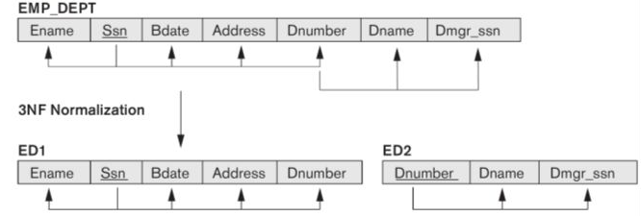
Figure. Normalizing EMP_DEPT into 3NF relations.
Example: The dependency SSN → DMGRSSN is transitive
because both the dependencies
SSN →DNUMBER and
DNUMBER → DMGRSSN hold and
DNUMBER is neither a key itself nor a subset of the key of EMP_DEPT.
However, EMP_DEPT is not in 3NF because of the transitive dependency of DMGRSSN and also DNAME on SSN via DNUMBER.
We can normalize EMP_DEPT by decomposing it into the two 3NFrelation schemas EDl and ED2 shown in Figure.

Week 5
Validate the above design against integrity constraints
Validation is a process whereby the data entered in the database is checked to make sure that it is sensible. For example, validation can be utilized to check that only Male or Female is entered in a sex field. It cannot check whether or not the data entered is correct. It can only check whether or not the data makes sense.
Validation is a way of trying to lesson the number of errors during the process of data input.
The computer carries out validation when you input data. It is a way of checking the input data against the set of validation rules.
The purpose of validation is to make sure that data is
a) Logical,
b) Relational, and
c) Complete and within acceptable limits.

Database Validation Methods:

- Type – If you make a specific field numeric then it won’t allow you to input any letters or other non-numeric characters. Be wary when using the numeric data type. If you use it for fields like phone numbers, it won’t allow you to enter spaces, or other human-friendly forms of formatting.

- Some data types can carry out an extra type check. For example, a date data type will ensure that a date inputted existed at some point, or could exist in the future. It would not accept the date 30/02/2018.
- Presence – This is sometimes called Allow Blank or Mandatory. This type of validation compels the user to enter data in the required field.

- For example, in an address book, you can make either the address or phone number optional, while you must make the name field required. Leaving a mandatory field blank will trigger an error message that will prevent you from proceeding to the next step.

- Unique Identifier – It is essential that one record can be plainly recognized from another record. Generally speaking, each record has one field those functions as a unique identifier for a record. An easy validation check can be done to make sure that a value occurs only once in this field—it doesn’t matter if there are thousands of records in the database, the check can be carried out just the same.
- Range Check – Range check is a validation check, which can be applied to numeric fields. This is done to ensure that only numbers within a certain domain can be entered into a field. Remember that this does not necessarily mean that the data entered will be correct. But it will certainly lie within reasonable limits.
- Format – This is used for a field that requires an entry in a specific format. Examples include date format, postal codes, and driver’s license numbers.
- Referential Integrity – If you’re using a relational database, then you can impose referential integrity to validate inputs. You can check data inputs in certain fields against values in other tables. For example, in the job database, when a new hire is entered, you could check the supervisor name against the employee table, just like you could check the department name against the department table.

Why Validate?
Validating the accuracy, clarity, and details of data is necessary to mitigate any project defects. Without validating data, you run the risk of basing decisions on data with imperfections that are not accurately representative of the situation at hand.
While verifying data inputs and values is important, it is also necessary to validate the data model itself. If the data model is not structured or built correctly, you will run into issues when trying to use data files in various applications and software.
Example:
Validating referential integrity Constraints

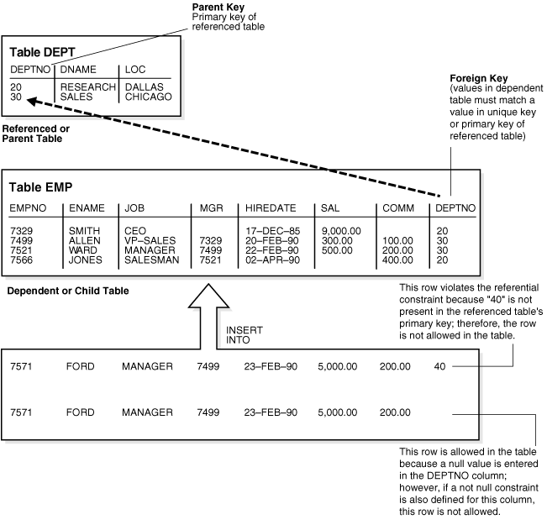

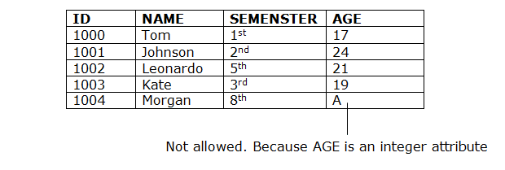
Domain Constraints:

Validating Key constraints:
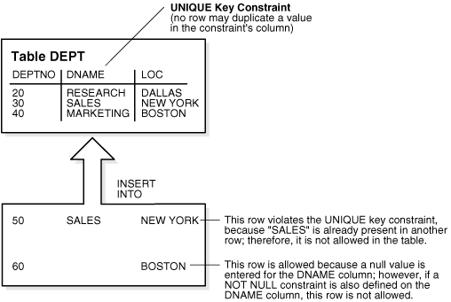

Week 6
Use MySQL/PostgreSQL DDL statements to create database and other DB objects for above design
CREATE Creates new databases, tables and views from DBMS.
For example −
Create database company;
Create table employee;
Create view works_on1;
The CREATE TABLE Command in SQL
The CREATE TABLE command is used to specify a new relation by giving it a name and specifying its attributes and initial constraints.
The attributes are specified first, and each attribute is given a name, a data type to specify its domain of values, and any attribute constraints, such as NOT NULL.
The key, entity integrity, and referential integrity constraints can be specified within the CREATE TABLE statement.
Syntax of create command as follows:
CREATE TABLE TABLENAME
(COLUMN1 DATATYPE(SIZE) [CONSTRAINT],
COLUMN2 DATATYPE (SIZE) [CONSTRAINT],
.
.
.
COLUMNN DATATYPE (SIZE) [CONSTRAINT]);
Example
CREATE TABLE EMPLOYEE(FNAME VARCHAR(15), LNAME VARCHAR(15));
Queries to create tables for Employee database:
Employee table creation
create table employee
(
name varchar(10) NOT NULL,
ssn char(9) NOT NULL,
bdate date,
address varchar(30),
sex char,
salary int,
superssn_char(9),
dno int NOT NULL,
primary key(ssn),
foreign key(super_ssn) references employee(ssn)
);
Department table creation
create table department
(
Dname varchar(15) NOT NULL,
Dnumber int NOT NULL,
mgr_ssn char(9) NOT NULL,
mgr_start_date date,
primary key(dnumber),
foreign key(mgr_ssn) references employee(ssn)
);

Department location table creation
create table dep_locations
(
Dnumber int NOT NULL,
Dlocation varchar(15) NOT NULL,
primary key(dnumber, dlocation),
foreign key(dnumber) references department(dnumber)
);

Project table creation
create table project
(
Pname varchar(15) NOT NULL,
Pnumber int NOT NULL,
Plocation varchar(15),
Dnum int NOT NULL,
primary key(pnumber),
foreign key(dnum) references department(dnumber)
);

Works on table creation
create table works_on
(
Essn char(9) NOT NULL,
Pno int NOT NULL,
hours decimal(3,1) NOT NULL,
primary key(essn,pno),
foreign key(pno) references project(pnumber)
);

Dependent table creation
create table dependent
(
Essn char(9) NOT NULL,
dependent_name varchar(15) NOT NULL,
bdate date,
relationship varchar(8),
primary key(essn,dependent_name),
foreign key(essn) references employee(ssn)
);

Illustrate the use of constraints:
NOT NULL, PRIMARY KEY,UNIQUE,CHECK,DEFAULT,REFERENCES
Person table creation
create table person(
fname varchar(15) NOT NULL,
mint char(2),
lname varchar(15),
ssn char(9),
bdate date,
address varchar(30),
adhar_no int NOT NULL,
sex char(1),
exp int,
super_ssn char(9),
salary int DEFAULT 10000,
PRIMARY KEY(ssn),
UNIQUE(adhar_no),
CHECK(exp>2),
FOREIGN KEY(super_ssn) references person(ssn)
);
CREATE TABLE
Query returned successfully in 124 msec.
1) insert into person values('geetha','k','gowda','11112222','12/06/1999', Bangalore','1325122315','f','4','11112222','15000');

INSERT 0 1
Query returned successfully in 63 msec.

select * from person;

NOT NULL CONSTRAINT VIOLATION

- insert into person(ssn) values('155160019');
ERROR: null value in column "fname" of relation "person" violates not-null constraint DETAIL: Failing row contains (null, null, null, 155160019, null, null, null, null, null, null, 10000). SQL state: 23502

- insert into person(fname, ssn) values('gowtham','11112111');
ERROR: null value in column "adhar_no" of relation "person" violates not-null constraint DETAIL: Failing row contains (gowtham, null, null, 11112111 , null, null, null, null, null, null, 10000). SQL state: 23502

- insert into person(fname, ssn, adhar_no) values('gowtham','222233333','136454545');
INSERT 0 1
Query returned successfully in 87 msec.

4) insert into person(fname,ssn,adhar_no) values('manoj','33334444','1353454541');
5) insert into person(fname,ssn,adhar_no) values('naveen','44445555','1787878985');

CHECK CONSTRAINT VIOLATION
- insert into person values('hemanth','C','K','33334444',’12/03/2000',’MYSORE','1325122315','m','1','11112222',’15000');
ERROR: new row for relation "person" violates check constraint "person_exp_check" DETAIL: Failing row contains (hemanth, C , K, 33334444 , 2000-03-12, MYSORE, 1325122315, m, 1, 11112222 , 15000). SQL state: 23514

UNIQUE CONSTRAINT VIOLATION
- insert into person
values('abhi','l','g','33334444','25/09/1999','RAMANAGAR','1325122315','m','4','11112222','15000');
ERROR: duplicate key value violates unique constraint "person_adhar_no_key" DETAIL: Key (adhar_no)=(1325122315) already exists. SQL state: 23505
PRIMARY KEY CONSTRAINT VIOLATION
- Insert into person
values('bharth','k','gowda','11112222','27/12/1999','MANDYA','1325122316','m','4','11112222','15000');
ERROR: duplicate key value violates unique constraint "person_pkey"
DETAIL: Key (ssn)=(11112222 ) already exists. SQL state: 23505
- Insert into person(fname, ssn, adhar_no) values('gowtham',null,'1516100001');
ERROR: null value in column "ssn" of relation "person" violates not-null constraint DETAIL: Failing row contains (gowtham, null, null, null, null, null, 1516100001, null, null, null, 10000). SQL state: 23502
FOREIGN KEY CONSTRAINT VIOLATION
- Insert into person
values('naveen','d','r','155160094','25/09/1999','turvekere','1325122320','m','4','155160023','15000');
ERROR: insert or update on table "person" violates foreign key constraint "person_super_ssn_fkey" DETAIL: Key (super_ssn)=(22224444 ) is not present in table "person". SQL state: 23503
DEFAULT
- insert into person(fname,ssn,adhar_no) values('gowtham','155160019','136454545');
- insert into person(fname,ssn,adhar_no) values('manoj','155160024','8135345454');
- insert into person(fname,ssn,adhar_no) values('naveen','155160023','1787878985');

Week 7
Perform insert, delete and/or update operations on the database and query the database to retrieve the required information using appropriate SQL statements and clauses

INSERT INTO – General Syntax
The INSERT
INTO statement is used to insert new records in a table. It is possible to write the INSERT INTO statement in two ways:
Specify both the column names and the values to be inserted:
INSERT INTO table_name(column1, column2, column3, ...)
VALUES(value1, value2,value3, ...);
1.Inserting values into a employee table
- INSERT INTO EMPLOYEE
VALUES
('RASHMI','111111','12-4-95','RAMANAGAR','F',60000,'111111',2);
- INSERT INTO EMPLOYEE(NAME, SSN, bdate, ADDRESS, SEX, SALARY, SUPER_SSN, DNO)
Values
('AMAR','222222','12-3-91','MAGADI','M',50000,111111,3),
('JAYANTH','333333','12-3-85','TUMKUR','M',80000,111111,5),
('HARSHA','555555','12-4-80','MANDYA','M',60000,333333,1),
('RACHANA','444444','12-5-90','BANGALORE','F',60000,222222,4);
- INSERT INTO EMPLOYEE(NAME, SSN, bdate, ADDRESS, SEX, SALARY, SUPER_SSN, DNO)
values
('HAMSA',666666','12-5-90','MANDYA','F',60000,222222,4),
('MENAKA','777777','5-4-86','RAMANAGAR','F',65000,333333,2),
('MANJU','888888’,'5-4-86','BANGALLORE','M',60000,111111,1);

2. Inserting values into a department table
INSERT INTO DEPARTMENT (DNAME, DNUMBER, MGR_SSN, MGR_START_DATE)
values
('RESEARCH', 1, '111111', '12-04-2012');
INSERT INTO DEPARTMENT (DNAME, DNUMBER, MGR_SSN, MGR_START_DATE)
values
('ACCOUNTS', 2, '222222','12-04-2013'),
('PURCHASE', 3, '333333', '13-5-2015'),
('NETWORKS', 4, '111111', '13-4-2013'),
('BIGDATA', 5, '444444', '11-5-2012');

3. Inserting values into a department location table
INSERT INTO DEP_LOCATIONS(DNUMBER,DLOCATION)
VALUES
(1, 'BANGALORE'),
(2, 'MYSORE'),
(3, 'TUMKUR'),
(4, 'MANDYA'),
(5, 'HASSAN');

- Inserting values into a project table
INSERT INTO PROJECT (PNAME, PNUMBER, PLOCATION, DNUM)
VALUES
('ANDROID', 11, 'BANGALORE', 1),
('JAVA', 22, 'PUNE', 2),
('WEB', 33, 'CHENNAI', 3),
('IPSEC', 44, 'KOCHI', 4),
('TEXTSPEECH', 55, 'HYDERABAD', 5);

- Inserting values into a works_on table
INSERT INTO works_on(essn,Pno,hours)
VALUES
('111111', 11, 15);
INSERT INTO works_on(essn,Pno,hours)
VALUES
('222222', 22, 10),
('333333', 33, 5),
('444444', 44, 8),
('555555', 55, 7);

- Inserting values into a dependent table
INSERT INTO dependent(essn,dependent_name,bdate,relationship)
VALUES
('222222', 'ASHISH', '13-07-93', 'BROTHER'),
('111111', 'BHAVYA', '10-07-91', 'SISTER'),
('333333', 'KAVYA', '13-04-95', 'SISTER'),
('444444', 'MAHESH', '12-03-92', 'BROTHER');

The DELETE Statement

DELETE Query is used to delete the existing records from a table.

DELETESyntax

DELETE FROM table_name WHERE[CONDITION];
delete from employee where ssn='555555';

UPDATE COMMAND

UPDATE Query is used to modify the existing records in a table. We can use WHERE clause with UPDATE query to update the selected rows.

UPDATE Syntax
UPDATE table_name
SET column1 = value1, column2 = value2, ...WHERE condition;
update employee set address='MYSORE'
WHERE ssn='444444';

Querying single table:
Examples:
Conditional retrieval - WHERE clause
- Retrieve all employees whose department number is 1
select * from employee where dno=1;
- Retrieve the date of birth, address of employee whose name is Jayanth..

select name, bdate, address
from employee
where name='JAYANTH';
- Retrieve names, ssn and department numbers of all employees.
select name, ssn, dno from employee where dno=2;
- Select distinct department number and name from employee
select distinct dno, name
from employee;
- Retrieve project name, project location from project table.
select pname, plocation
from project;
- Retrieve name, minit, last name salary from employee table.
select name, address, salary
from employee;

Sort the result set of a query:
ORDER BY clause
- Order the department number with project name in ascending order in project table.
select pname, dnum
from project
order by dnumasc;
- Order the employee first name in descending order.
select name
from employee
order by name desc;
- Select first name,ssn, address from employee table whose salary is greater than 11,000 and tuples in ascending order.
select name,salary, ssn,address
from employee
where salary>60000
order by name asc;
Select name,salary, ssn,address
from employee
where salary>60000
order by name desc;

Week 8
Querying single table, Filtering data, Query multiple tables with joins
- Querying single table
- Filtering data
- Query multiple tables with joins

Query:
A query is a request for data or information from a database table or combination of tables. This data may be generated as results returned by Structured Query Language (SQL) or as pictorials, graphs or complex results, e.g., trend analyses from data-mining tools.
One of several different query languages may be used to perform a range of simple to complex database queries. SQL, the most well-known and widely used query language, is familiar to most database administrators (DBAs).

Elements of the SELECT statement
The purpose of the SELECT statement is to query database tables, apply logical manipulation to the data, and result a result set.
SQL code is processed differently than most programming languages, where code is processed in the order they were written. In SQL, the clauses are logically processed in the following order:
- FROM
- WHERE
- GROUP BY
- HAVING
- SELECT
- ORDER BY

The FROM clause
The FROM clause is the query clause that is logically processed first, and this clause is used to specify the names of the tables we are querying, as well as the table operators that operate on those tables.

The WHERE clause
The WHERE clause is used to apply a predicate or logical expression to filter rows returned from the FROM clause. Only rows for which the predicate evaluates to TRUE are returned in the result set.

The GROUP BY clause
Using the GROUP BY clause we can group the records of the returned by the previous logical processing phase(s). The element(s) by which the records will be grouped are specified in the GROUP BY clause.

The HAVING clause

The WHERE clause is a row filter, whereas the HAVING clause is a group filter. Only groups that evaluated to TRUE by the HAVING predicate are returned to the next logical query phase (if one exists). Any group that evaluates to FALSE or UNKNOWN will not be returned. Because the HAVING clause is processed after rows have been grouped, we can apply aggregate functions in conjunction with the HAVING clause.

The SELECT clause
The SELECT clause is used to specify the attributes (columns) to return in the result set of a query. If the SELECT clause specifies an attribute with no manipulation, the name of the target attribute retains the same name as the name of the source attribute.

The ORDER BY clause
The ORDER BY clause is used to sort records of the result set for presentation purposes. The ORDER BY clause is the very last clause processed in the phases of logical query processing.
Examples:
Write a query to display the names (first_name, last_name) using name “First Name", "Last Name".
Write a query to get all employee details from the employee table order by first name, descending.

Filtering data:
Data filtering is the process of choosing a smaller part of your data set and using that subset for viewing or analysis. Filtering is generally (but not always) temporary – the complete data set is kept, but only part of it is used for the calculation.
Filtering data using the WHERE clause
SELECT <COLUMN_LIST>FROMTABLE_NAMEWHEREcondition
various use cases of the WHERE clause are given below.
- The WHERE clause with an equal operator
- The WHERE clause with AND, OR, and BETWEEN operators
- The WHERE clause with LIKE and IN operators
- The WHERE clause with comparison operators
POSTGRESSQL operators(And, Or, Like, Between, In)
- Show the resulting salaries if every employee working on the SQL project has given a 10% rise.
select name, 1.1*salary
from project, employee, works_on
where project.pnumber = works_on.pno and Works_on.essn=employee.ssn and pname='ANDROID';

- Retrieve all the employee working in department number 1 and 5.
select *
from employee
where dno='1' or dno='5';
- List all employees whose name have a first character is ‘H’ or second character has ‘a’ or ‘e’.

select *from employee
where name like 'H%' or name like '_A%' or name like '_ _N%';
- List all employee whose salary between 15000 and 30000.
- List all employee whose salary between 15000 and 30000.

select *
from employee
where salary between 15000 and 30000;

- Retrieve the social security number(essn) of employee who work on project numbers 11,44, 55.

select distinct essn
from works_on
where pno in(11,55,44);

Query multiple tables with joins
The joins allow us to combine data from two or more tables so that we are able to join data of the tables so that we can easily retrieve data from multiple tables.
there are four main types of joins
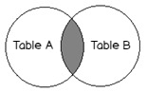
- Inner join returns the rows that match in both tables

- Right join returns all rows from the right table
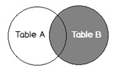

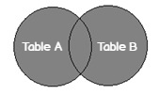
- Full join returns whole rows from both tables

Query multiple tables using JOIN operation
SELECTemployee.LastName,employee.DepartmentID,department.DepartmentName
FROM employee INNER JOIN department ON
Employee.Dno=department.Dnumber;
  - Retrieve name of employee those who are working in research department.
select name
from (employee join department on employee.dno=department.dnumber)
where dname='RESEARCH';

  - For every project located in Bangalore. List the project number controlling department number and the department manager last name and address.
select pnumber,dno,name,address
from (employee join project on employee.dno=project.dnum)
where plocation='BANGALORE';

Left outer join
select name,employee.dno,dname
from (employee left outer join department on employee.dno=department.dnumber);
Right outer join
select name,employee.dno,dname
from (employee right outer join department on employee.dno=department.dnumber);
Week 9
Queries that use set operators ,Report aggregated data using group functions
Report aggregated data using group functions
Aggregate functions in SQL (Count, Sum, Max, Min, Avg)
An aggregate function performs a calculation on a set of values, and returns a single value. Except for COUNT (*), aggregate functions ignore null values. Aggregate functions are often used with the GROUP BY clause of the SELECT statement
  - Find the sum of the salaries of all employees, the maximum salary,the minimum salary, and the average salary.
SELECT SUM (Salary), MAX (Salary), MIN (Salary), AVG (Salary)
FROM EMPLOYEE;
2. Find the total number of employee of a company.
select count(*)
from employee;
  - Count the number of distinct salary from employee table.
select count(distinct salary)
from employee;
  - Compute the salary of employee working in department number 1.
select sum(salary)
from employee
where dno='1';
5. Find the employee who is first and who is last in the alphabetical order.
select min(name),max(name)
from employee;
6. For each project, retrieve the project number, the project name, and the number of employees who work on that project.
SELECT Pnumber, Pname, COUNT (*)
FROM PROJECT, WORKS_ON
WHERE Pnumber=Pno
GROUP BY Pnumber, Pname;
- For each department, retrieve the department number, the number of employees in the department, and their average salary.
SELECT Dno, COUNT (*), AVG (Salary)
FROM EMPLOYEE
GROUP BY Dno;
- Retrieve the total number of employees in the ‘Research’ department .
SELECT COUNT (*)
FROM EMPLOYEE,DEPARTMENT
WHERE DNO=DNUMBER AND DNAME='RESEARCH';

Week 10
Write sub queries to retrieve information from the created database (company)
1. Display employees whose salary is greater than the average salary.
SELECT name, Salary
FROM EMPLOYEE
WHERE Salary > (SELECT AVG(Salary) FROM EMPLOYEE);
2. Display employees who work in the same department as ‘MENAKA’.
SELECT name, DNo
FROM EMPLOYEE
WHERE DNo = (
SELECT DNo
FROM EMPLOYEE
WHERE name = 'MENAKA'
);
3. List departments that have at least one employee earning more than ₹60,000.
SELECT Dname
FROM DEPARTMENT
WHERE DNumber IN (
SELECT DNumber
FROM EMPLOYEE
WHERE Salary > 60000
);
4. Find employees who work on more than one project.
SELECT name
FROM EMPLOYEE
WHERE ssn IN (
SELECT Essn
FROM WORKS_ON
GROUP BY Essn
HAVING COUNT(Pno) > 1
);
5. Display employees who earn the maximum salary in their department.
SELECT name, DNo, Salary
FROM EMPLOYEE e
WHERE Salary = (
SELECT MAX(Salary)
FROM EMPLOYEE
WHERE DNo= e.DNo
);
6. Display the details of the department with the highest average salary.
SELECT *
FROM DEPARTMENT
WHERE DNumber = (
SELECT DNo
FROM EMPLOYEE
GROUP BY DNo
ORDER BY AVG(Salary) DESC
LIMIT 1
);
7. List employees who are working on the ‘WEB’ project.
SELECT name
FROM EMPLOYEE
WHERE ssn IN (
SELECT Essn
FROM WORKS_ON
WHERE Pno = (
SELECT Pno
FROM PROJECT
WHERE Pname = 'WEB'
)
);

8. Display employees whose salary equals the minimum salary in the company.
SELECT name, Salary
FROM EMPLOYEE
WHERE Salary = (
SELECT MIN(Salary)
FROM EMPLOYEE
);
9. Show project names handled by the ‘Research’ department.
SELECT Pname
FROM PROJECT
WHERE DNum = (
SELECT DNumber
FROM DEPARTMENT
WHERE Dname = 'Research'
);

10. Find employees who do not work on any project.
SELECT name
FROM EMPLOYEE
WHERE ssn NOT IN (
SELECT Essn
FROM WORKS_ON
);

Week 11
- Create view and query
- Create users and assign privileges for DB operations
Create a view for employees and their department names
CREATE VIEW emp_dept_view AS
SELECT e.name, e.Salary, d.Dname
FROM EMPLOYEE e
JOIN DEPARTMENT d ON e.DNo = d.DNumber;
Query the view
SELECT * FROM emp_dept_view;
You can also apply filters:
SELECT Ename, Dname, Salary
FROM emp_dept_view
WHERE Salary > 60000;
Drop the view (if needed)
DROP VIEW emp_dept_view;

Create Users and Assign Privileges
Step 1: Create a new user
CREATE USER 'manager'@'localhost' IDENTIFIED BY 'manager123';
CREATE USER 'staff'@'localhost' IDENTIFIED BY 'staff123';
Step 2: Grant privileges
Grant full privileges on the Company database to manager:
GRANT ALL PRIVILEGES ON company.* TO 'manager'@'localhost';
Grant limited privileges (only SELECT and INSERT) to staff:
GRANT SELECT, INSERT ON company.* TO 'staff'@'localhost';
Step 3: Apply changes
FLUSH PRIVILEGES;
✅ Step 4: Check granted privileges
SHOW GRANTS FOR 'manager'@'localhost';
SHOW GRANTS FOR 'staff'@'localhost';
✅ Step 5: Revoke privilege (if needed)
REVOKE INSERT ON company.* FROM 'staff'@'localhost';
✅ Step 6: Drop a user (if needed)
DROP USER 'staff'@'localhost';

Week 12
- Create and execute store procedures
- Create and execute functions

Create and Execute a Stored Procedure
What is a Stored Procedure?
A Stored Procedure is a precompiled SQL program stored in the database.
You can call it to perform operations like inserting, updating, or retrieving data.
1. Stored Procedure to Display All Employees
DELIMITER //

CREATE PROCEDURE GetAllEmployees()
SELECT * FROM EMPLOYEE;
END //
DELIMITER ;

Execute the procedure
CALL GetAllEmployees();

2. Stored Procedure with a Parameter
Display employees with salary greater than a given amount.
DELIMITER //
CREATE PROCEDURE GetHighSalaryEmployees(IN minSalary DECIMAL(10,2))
SELECT name, Salary
FROM EMPLOYEE
WHERE Salary > minSalary;
END //

DELIMITER;

Execute the procedure
CALL GetHighSalaryEmployees(50000);

Stored Procedure to Insert New Employee
DELIMITER //

CREATE PROCEDURE AddEmployee(
IN p_name VARCHAR(10),
IN p_ssn CHAR(9),
IN p_salary INT,
IN p_dno INT
)
INSERT INTO EMPLOYEE(name, ssn, salary, dno)
VALUES (p_name, p_ssn, p_salary, p_dno);
END //

DELIMITER ;

Execute the procedure
CALL AddEmployee('Anil', '123456789', 45000, 2);
SELECT * FROM EMPLOYEE WHERE name = 'Anil';

Create and Execute a Function

What is a Function?
A Function returns a single value.
It can be used inside SQL statements (unlike procedures).

1. Function to Get Annual Salary of an Employee
DELIMITER //
CREATE FUNCTION AnnualSalary(monthly DECIMAL(10,2))
RETURNS DECIMAL(10,2)
DETERMINISTIC
RETURN monthly * 12;
END //
DELIMITER ;

Execute the function
SELECT AnnualSalary(40000) AS Annual_Income;

Drop a procedure or function (if needed)
DROP PROCEDURE GetAllEmployees;
DROP FUNCTION AnnualSalary;

Week 13
- Create and execute transactions
- Call previously created store procedure or function in transaction
Create and Execute a Transaction
A Transaction is a sequence of SQL statements that are executed as a single unit of work.
If any statement fails, the entire transaction can be rolled back to maintain data integrity.
Step 1: Start the Transaction
USE company;
START TRANSACTION;
Step 2: Execute SQL Statements
Example — insert two employee records.
INSERT INTO EMPLOYEE(name, ssn, salary, dno) VALUES ('Kiran', '131313', 55000, 2);
INSERT INTO EMPLOYEE(name, ssn, salary, dno) VALUES ('Manu', '121212', 30000, 3);
Step 3: Check Current Changes
SELECT * FROM EMPLOYEE;
At this stage, changes are not yet permanent.
Step 4: Use COMMIT to Save Changes
COMMIT;
This makes the transaction permanent in the database.
Step 5: Use ROLLBACK to Undo Changes
If something goes wrong, undo uncommitted changes:
ROLLBACK;
Step 6: Use SAVEPOINT to Mark a Stage
START TRANSACTION;
INSERT INTO EMPLOYEE(name, ssn, Salary, DNo) VALUES ('Latha', ‘123123’, 45000, 1);
SAVEPOINT first_insert;
INSERT INTO EMPLOYEE(name, ssn, Salary, DNo) VALUES ('Arun', '123412', 80000, 2);
-- Rollback to a specific point
ROLLBACK TO first_insert;
COMMIT;

2. Call Stored Procedure or Function in a Transaction
Step 1: Start a Transaction
START TRANSACTION;
Step 2: Call a Stored Procedure
(Example: GetHighSalaryEmployees procedure created earlier)
CALL GetHighSalaryEmployees(50000);
You can perform other operations after this call.
Step 3: Call a Function
(Example: AnnualSalary function created earlier)
SELECT AnnualSalary(40000) AS Annual_Income;
Step 4: Insert or Update Data Within Transaction
INSERT INTO EMPLOYEE(Ename, Job, Salary, DeptNo)
VALUES ('Ravi', 'Technician', 32000, 2);
Step 5: Commit or Rollback
If all operations are correct:
COMMIT;
If any error occurs:
ROLLBACK;

